New Brighton Primary School Inclusion Statement.

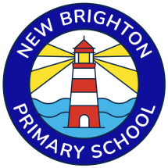

New Brighton Primary School is a highly inclusive school which focuses on the well-being and progress of every child. We have very high expectations of all our children, including those with Special Educational Needs or a Disability (SEND). All children have equal access to a broad and balanced curriculum.

To ensure all of our children achieve their potential we engage a range of strategies to provide challenges at an appropriate level, and provide support to help them overcome any barriers to learning.
Children with SEND are supported within their own class but sometimes may be supported for short periods with a specialist adult, individually or in a small group as part of an intervention.

In addition to children accessing 'Quality First Teaching' in our main classrooms, we also have two specialist enhanced provisions (An SLCN base and an MLD base).These provide highly specialised education and bespoke support for children with more complex SEND.
This provision is overseen by a teacher and our SENDCo and Assistant Head Mrs Kate Elsender.

